**Assignment 10.1 oozie**

Implement the concept given in below blog link and share the complete steps along with

screenshots.

<https://acadgild.com/blog/oozie-job-scheduling-in-hive/>

gedit create_table.hql

use default;

create table hive_oozie(

id INT,

name STRING)

ROW FORMAT DELIMITED FIELDS TERMINATED BY ',';

gedit workflows.xml

* **Create a directory in HDFS by firing below command.**

***hadoop fs -mkdir* hdfs://localhost:8020/workflows**

hadoop fs -put workflow.xml hdfs://localhost:8020/workflows/

hadoop fs -put create_table.hql hdfs://localhost:8020/workflows/

hadoop fs -put */etc/hive/conf.dist/hive-site.xml* hdfs://localhost:8020/workflows/

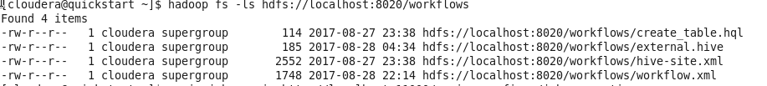

**Job.properties**

nameNode=hdfs://localhost:8020

jobTracker=localhost:8032

oozie.libpath=true

oozie.wf.application.path=${nameNode}/workflows

appPath=${nameNode}/workflows

***sudo service oozie start***

***Job run command:***

***oozie job -oozie*** [***http://localhost:11000/oozie -config ~/*job.properties**](http://localhost:11000/oozie%20-config%20~/job.properties)**-run**



